**PROJECT REPORT**

### **Implementing CRM For Result Tracking Of A Candidate With Internal Marks - (DEV)**

**1. INTRODUCTION**

**1.1. OVERVIEW**

Candidate Result Tracking is a specialized Salesforce software solution tailored to support educational institutions in effectively overseeing student outcomes. This comprehensive tool streamlines the entire result management process, spanning from creating examination schedules to disseminating final results. The software proves invaluable in efficiently managing extensive student datasets, encompassing personal particulars, enrollment specifics, and scholastic achievements.

**1.2. PURPOSE**

This software serves a multifaceted purpose, including safeguarding data through backup mechanisms during unforeseen scenarios, fortifying data security against unauthorized breaches and cyber threats, ensuring data retention, implementing stringent data access controls, facilitating data categorization, and ensuring alignment with all legal protocols and procedures.

**2. PROJECT DESCRIPTION & DESIGN THINKING**

**2.1. PROJECT DESCRIPTION**

The administrator should be able to create all base data including Semester, Candidate, Course and Lecturer ,Lecturer should have the ability to create Internal Results, Dean, who is one of the Lecturer, should be the only one with ability to update Internal Results, Re-evaluation Can be initialized by Candidate for all Internal Results. Now only the dean can update the marks after re- evaluation.

**2.2. ENTITY RELATIONSHIP DIAGRAM**

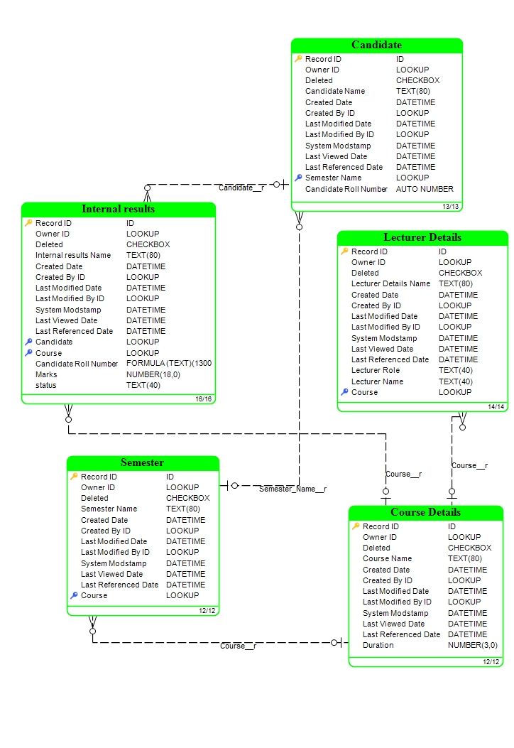

***Fig: Entity Relationship Diagram of the project.***

**2.3. TABULAR FORMAT**

| **OBJECT NAME** | **FIELD NAME** | **DATA TYPE** |
| --- | --- | --- |
| **Semester** | Semester Name | Text(Standard field) |
| Course | Lookup(Course Details) |
| **Candidate** | Candidate Name | Text(Standard field) |
| Candidate Roll Number | Auto Number |
| Semester Name | Lookup(Semester) |
| **Lecturer Details** | Lecturer Name | Text(Standard field) |
| Lecturer Role | Text |
| Course | Lookup(Course) |
| **Course Details** | Course Name | Text(Standard field) |
| Duration (Years) | Number |
| **Internal results** | Candidate | Lookup (candidate) |
| Candidate Roll Number | Formula |
| Course | Lookup(Course) |
| Marks | Number |
| Status | Text |

***Table: Objects and fields created.***

**3. ACTIVITY AND SCREENSHOTS**

**3.1. CREATION OF OBJECTS AND FIELDS FOR CANDIDATE INTERNAL RESULT CARD**

**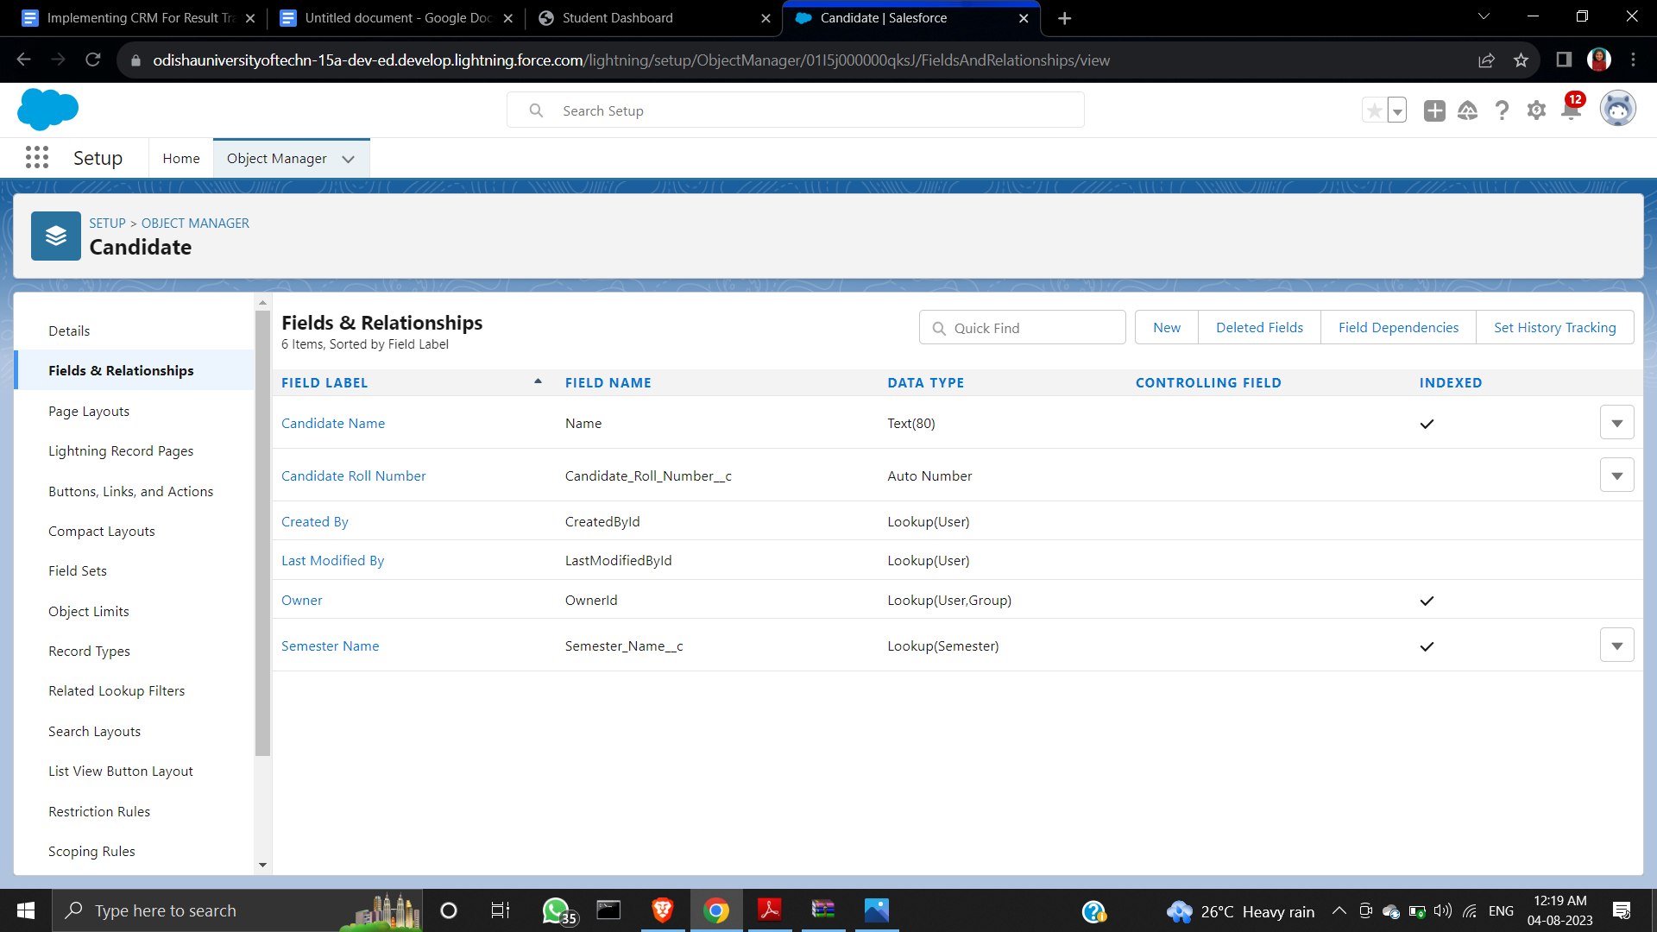*Fig: All the fields for the Candidate object are created***

**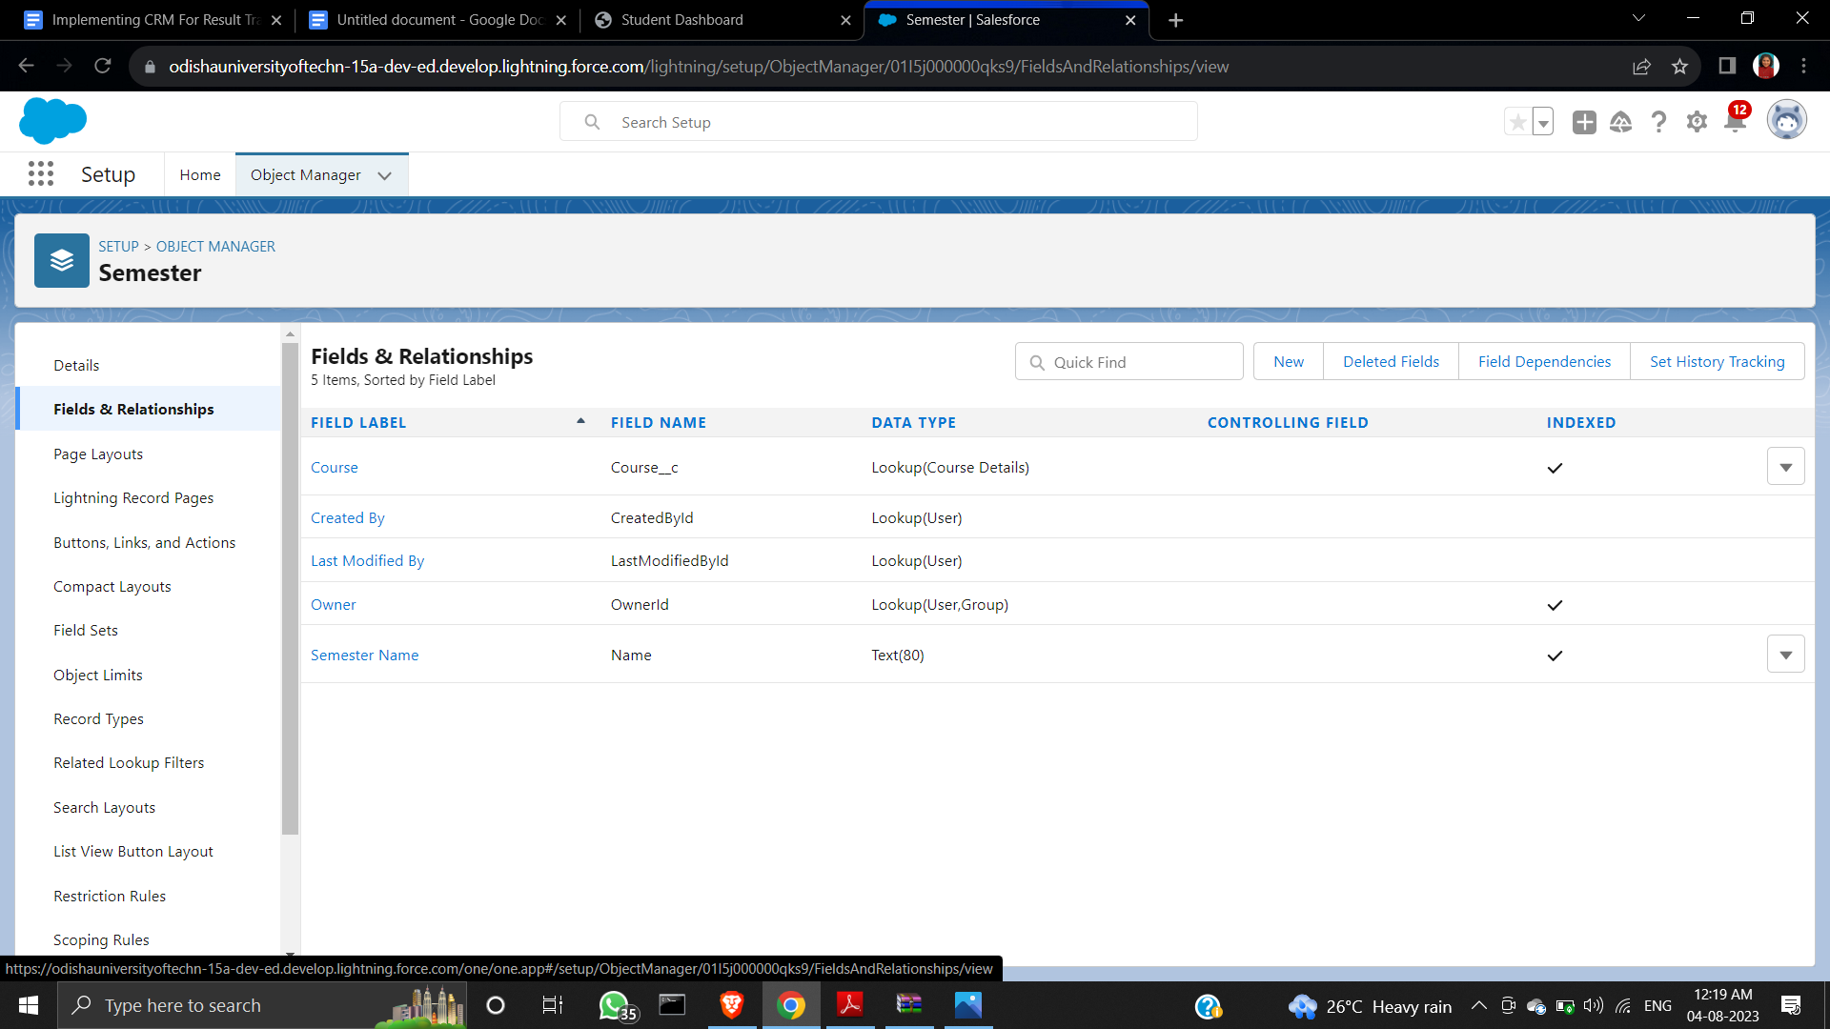*Fig: All the fields for the Semester object are created***

**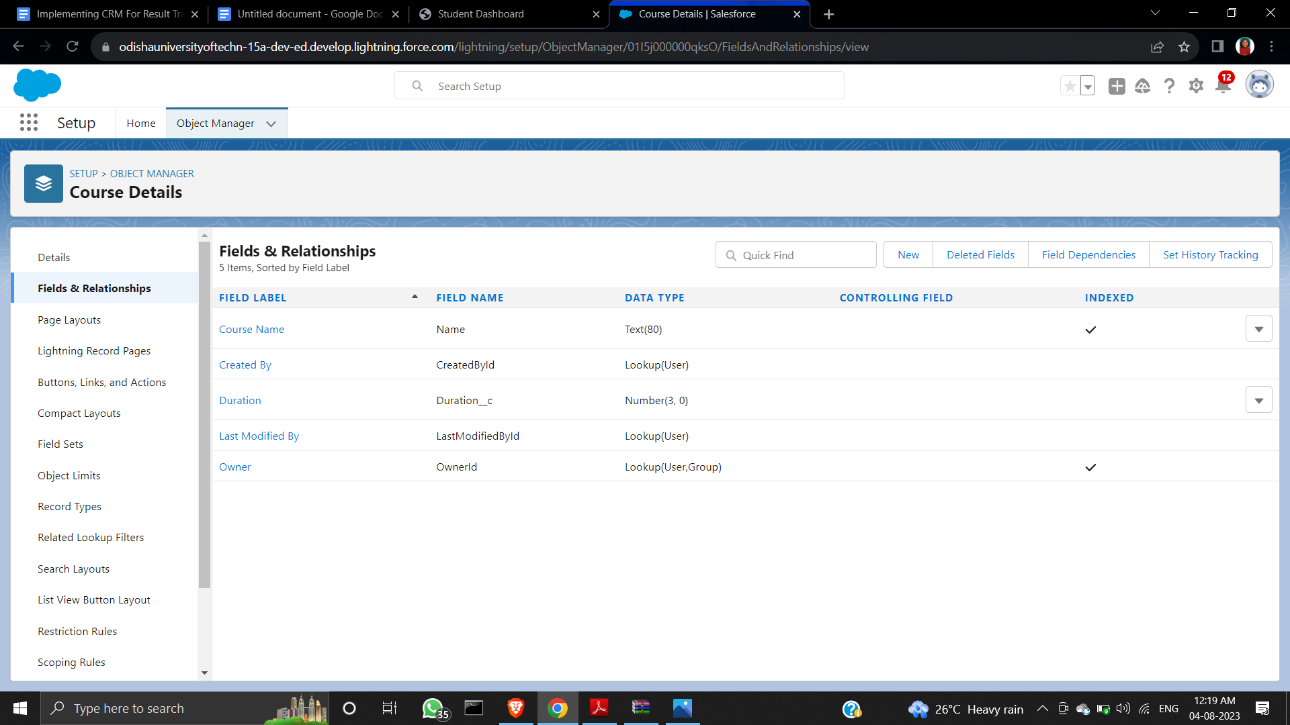*Fig: All the fields for the Course Detail object are created***

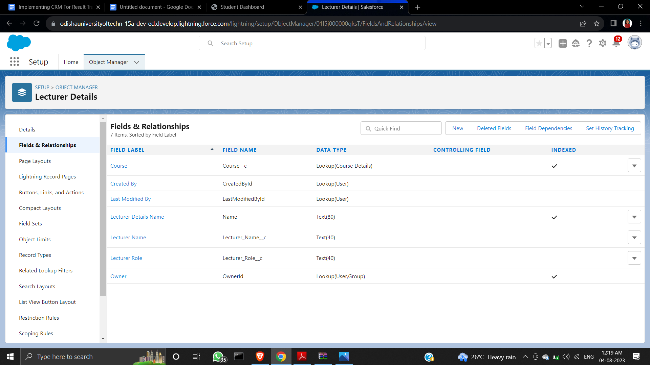***Fig: All the fields for the Lecturer Detail object are created***

**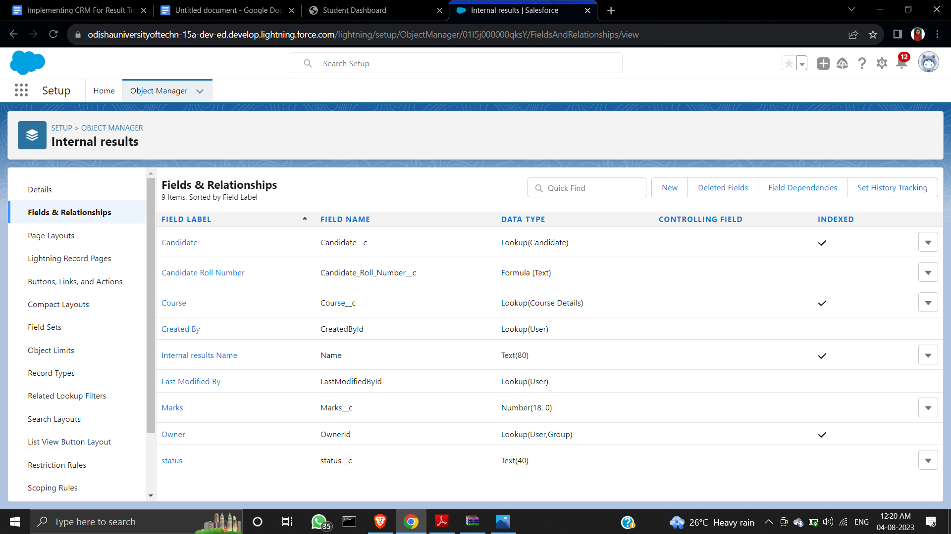*Fig: All the fields for the Internal Results object are created***

**3.2. CREATION OF TABS IN THE LIGHTNING APP**

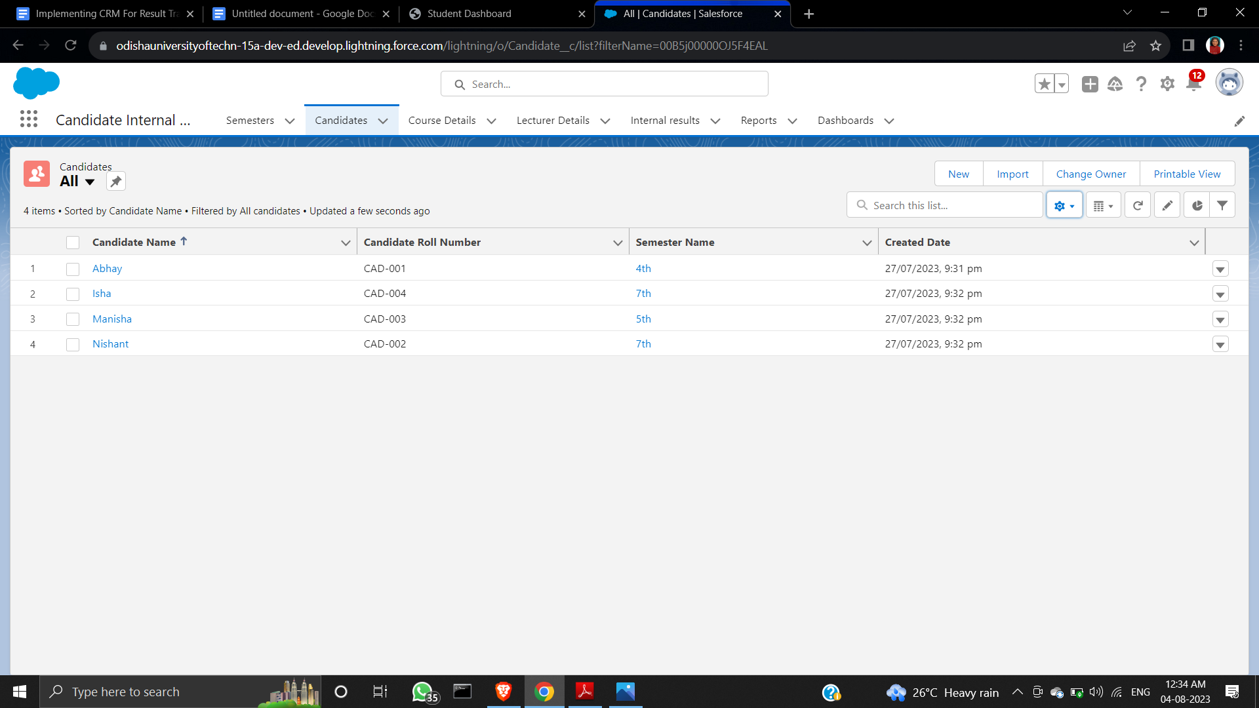

***Fig: The lightning app is created according to procedure***

**3.3. CREATION OF A USER**

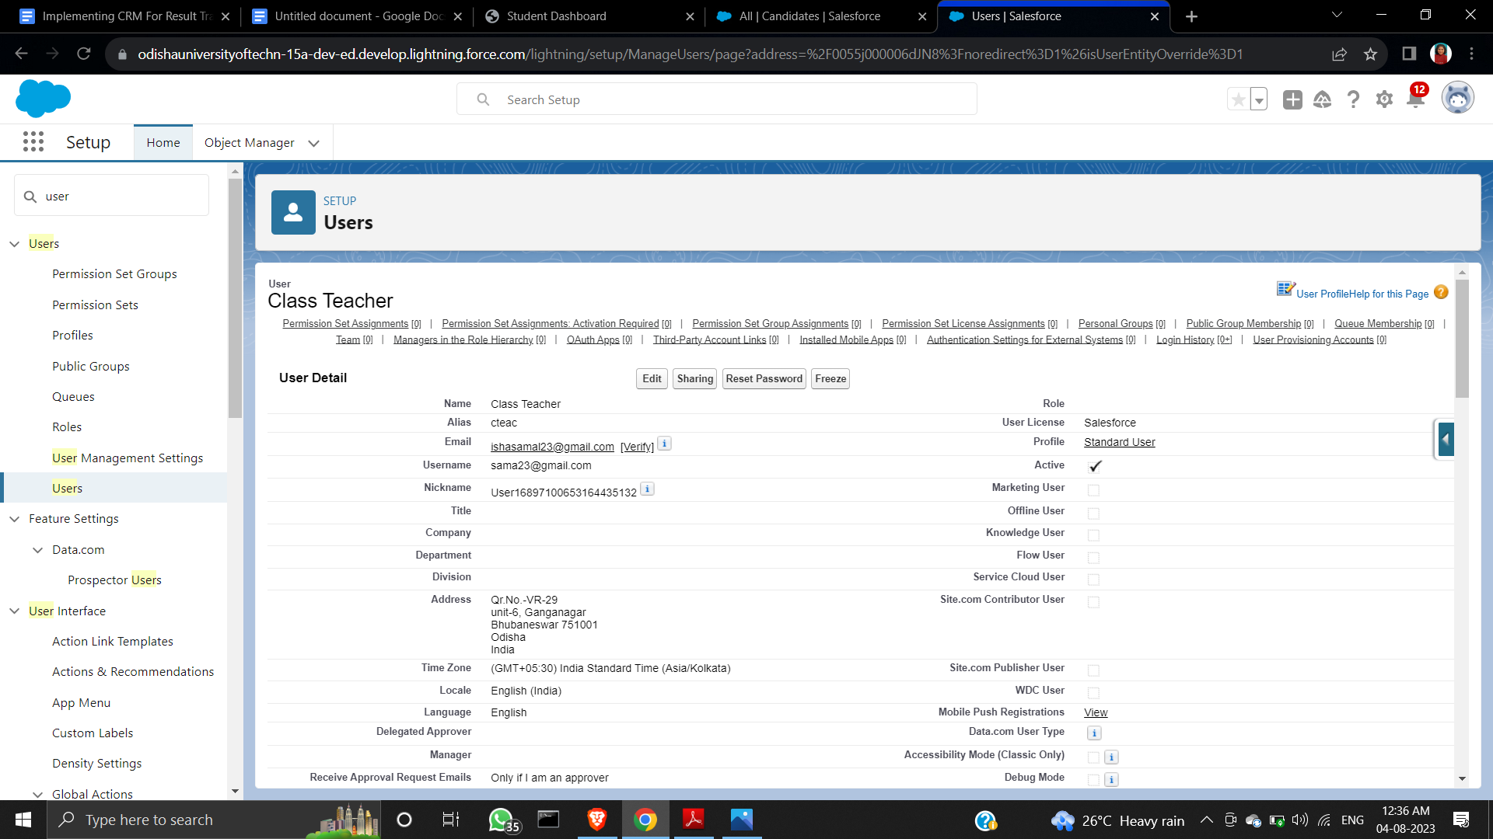

***Fig: Class Teacher user was created and the User License is set as salesforce***

**3.4. CREATION OF REPORT IN CANDIDATE INTERNAL RESULT CARD APP**

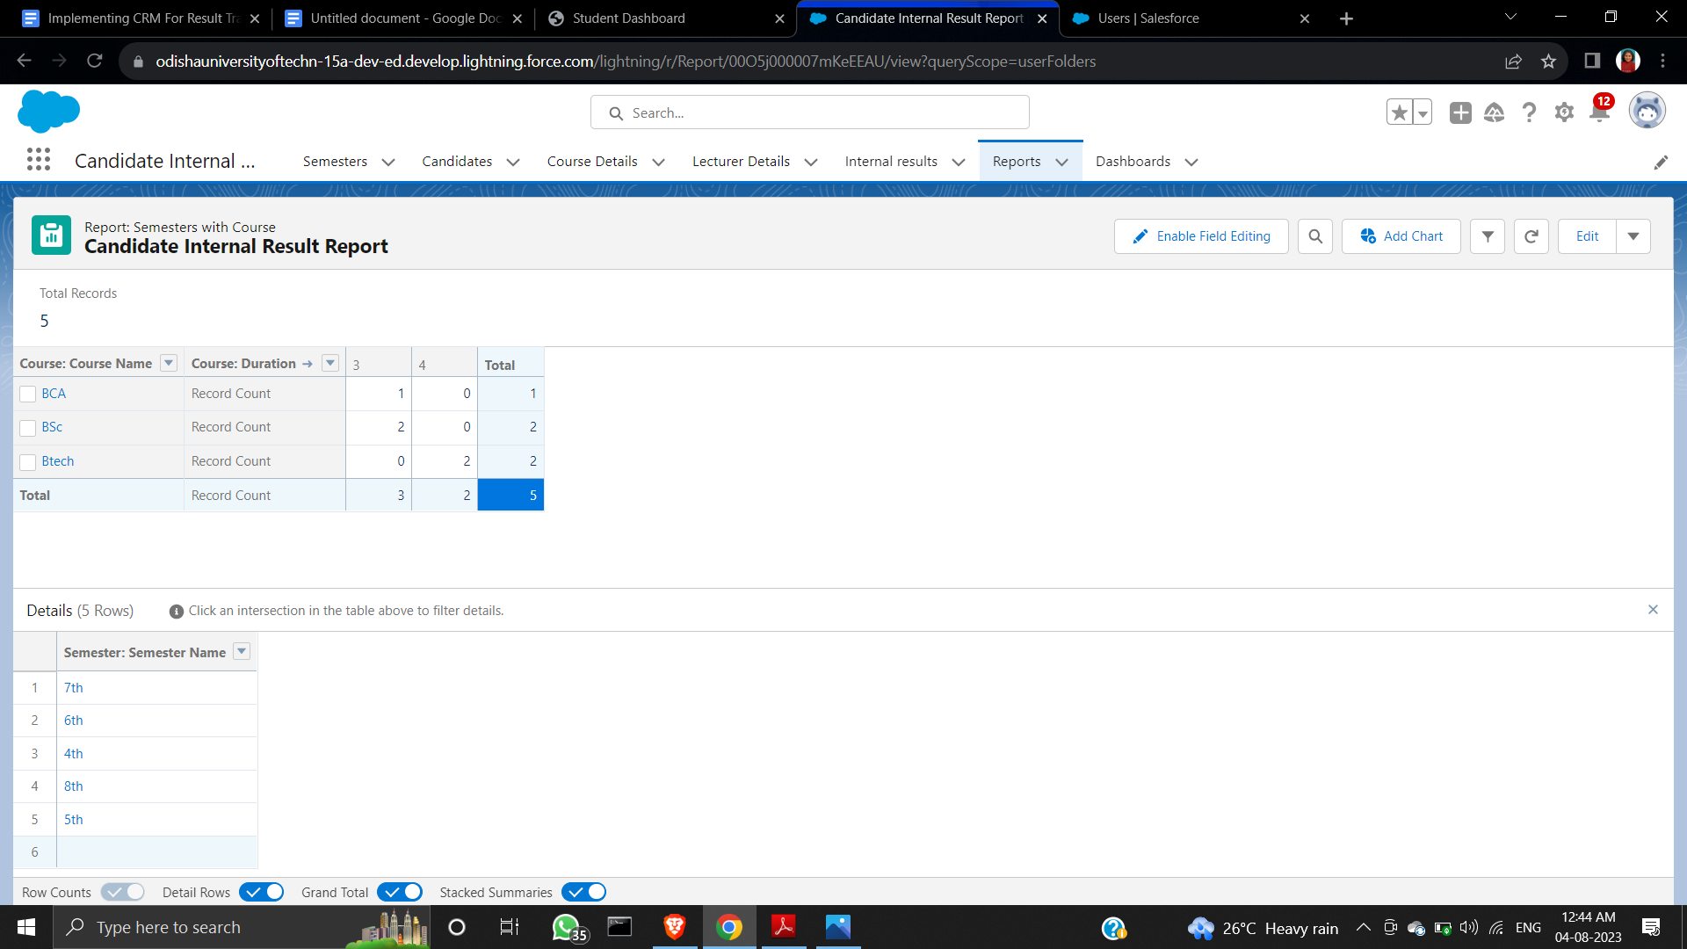

***Fig: The Candidate Internal Result Report is created***

**3.5. CREATION OF DASHBOARD IN CANDIDATE INTERNAL RESULT CARD APP**

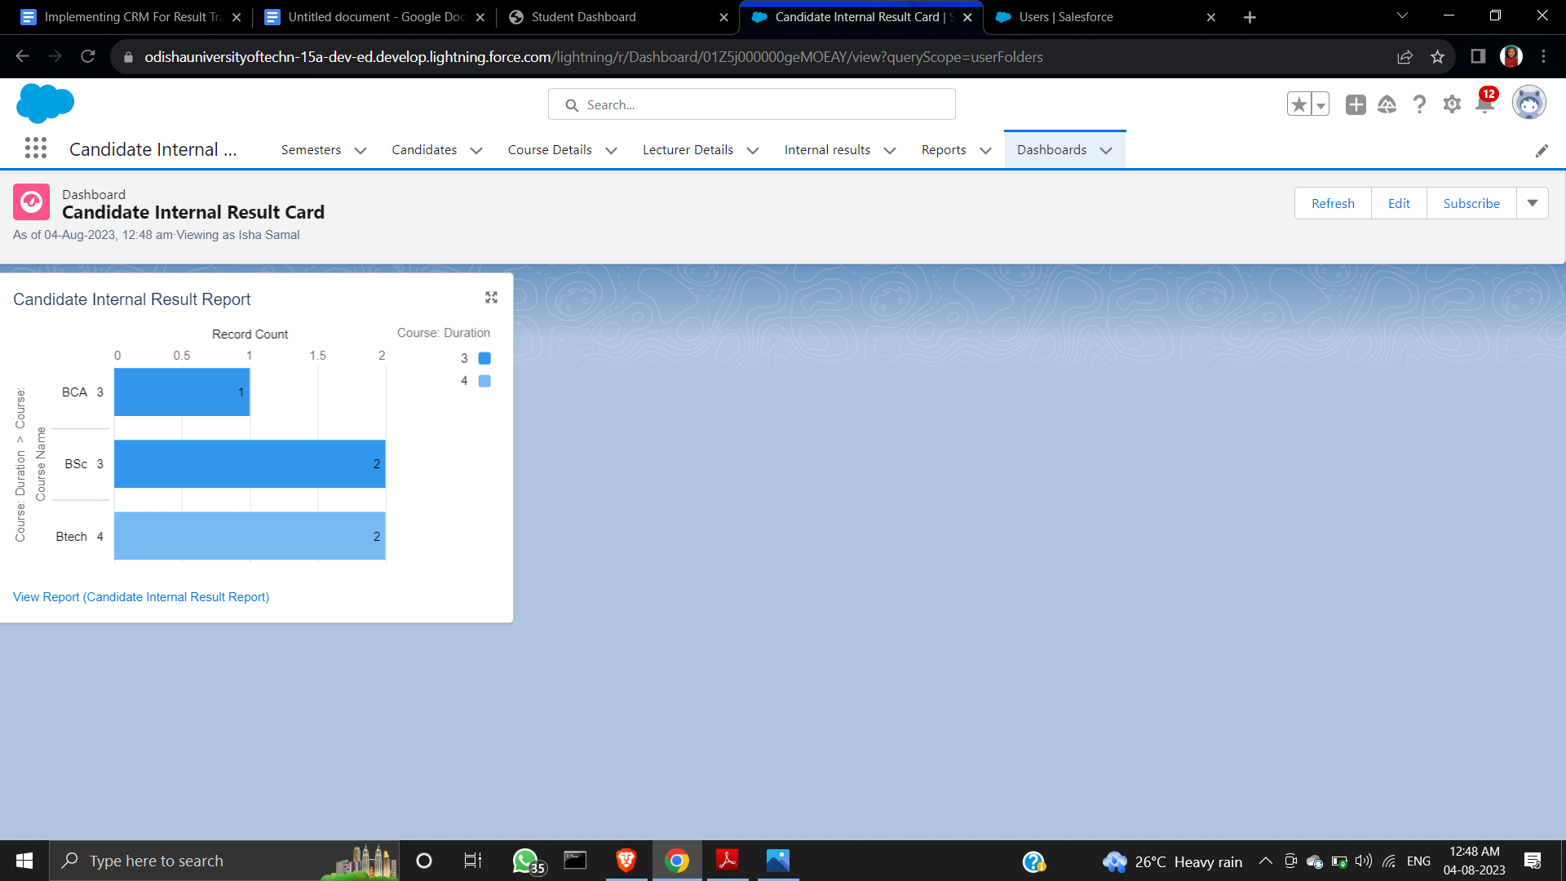

***Fig: In dashboard horizontal Bar Chart is added in the Candidate Internal Result Card***

**3.6. CREATION OF FIELD UPDATE USING TRIGGER**

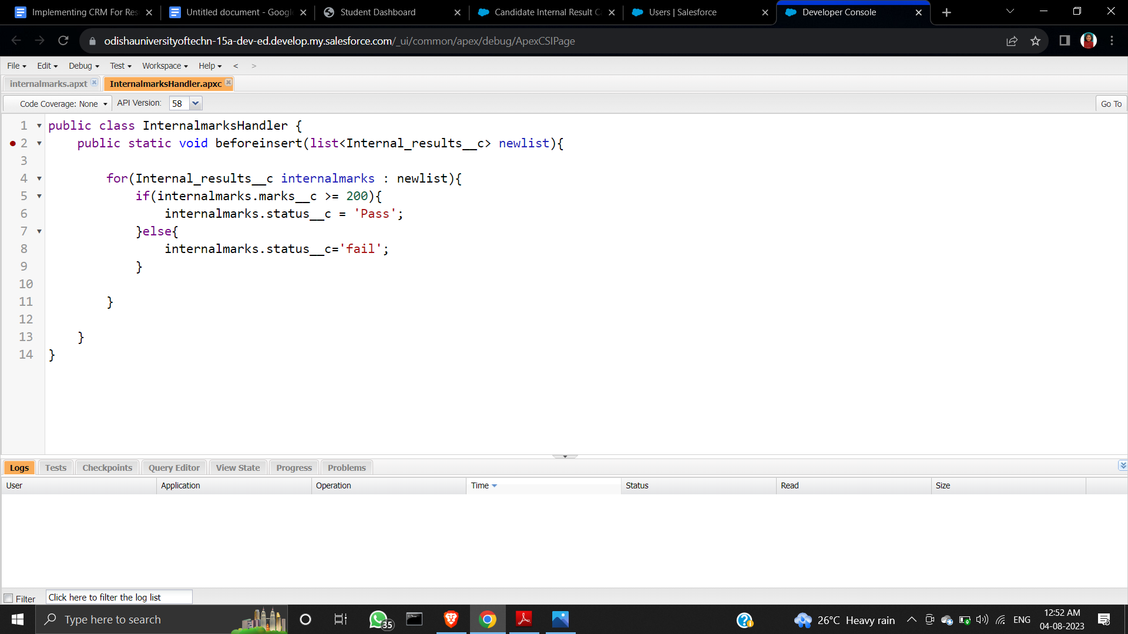

***Fig: the Apex class named as InternalmarksHandler is created***

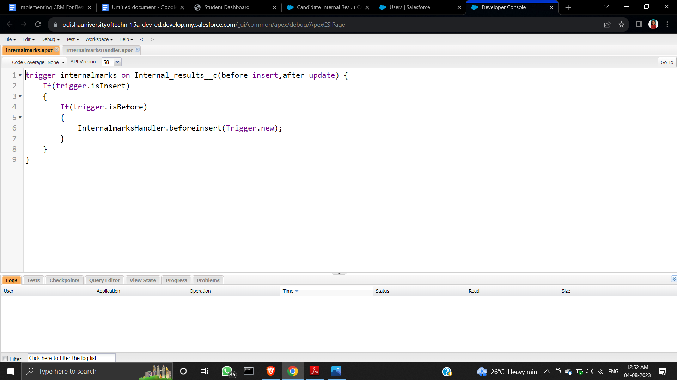

***Fig: the Apex trigger named as Internalmarks is created***

**4. TRAILHEAD PROFILE PUBLIC URL**

**Trailhead ID:** <https://www.salesforce.com/trailblazer/ishasamal23>

**5. ADVANTAGES**

* Streamlines result processing by automating the procedure, conserving valuable time and resources.
* Enhances precision by minimizing the potential for human errors.
* Ensures data security and proficient management of student records.
* Delivers performance analysis for pinpointing areas necessitating extra student assistance.
* Amplifies communication among students, parents, and faculty members.
* Elevates the holistic standard of education.

**6. DISADVANTAGES**

* Effective utilization of the software demands thorough training and specialized proficiency.
* The adoption of result management software carries a financial implication.
* The intricacy of result management software introduces the possibility of technical challenges like system disruptions or software glitches, potentially leading to processing setbacks or inaccuracies.

**7. APPLICATIONS**

* Educational Institutions: Streamline internal result tracking for students, aiding educators in evaluating academic progress and providing targeted support.
* Performance Analysis: Provide detailed insights into individual strengths and weaknesses, enabling personalized guidance and improvement strategies.
* Resource Optimization: Efficiently manage student data and academic records, optimizing administrative processes and resource allocation.
* Error Reduction: Minimize manual errors in result processing, ensuring accurate and reliable evaluation.
* Data Security: Safeguard sensitive student information through a secure digital platform.
* Efficient Reporting: Generate comprehensive and customizable reports for internal analysis and compliance purposes.

**8. CONCLUSION**

Incorporating a CRM system for tracking candidate results, including internal marks, through Salesforce yields a transformative solution for educational institutions. This project streamlines result management, enhances communication, and provides insightful analytics, ultimately fostering improved student engagement, informed decision-making, and an elevated educational experience.

**9. FUTURE** **SCOPES**

* Integration with Learning Management Systems (LMS): Enhance the project's scope by integrating with popular LMS platforms to create a comprehensive educational ecosystem.
* Predictive Analytics for Student Performance: Implement advanced analytics to predict student performance trends and provide proactive support.
* AI-driven Personalized Recommendations: Utilize artificial intelligence to offer tailored study resources and strategies based on individual student needs.
* Expanded Data Insights: Extend data analysis capabilities to gain deeper insights into student behavior, enabling more effective decision-making.
* Mobile App Accessibility: Develop a dedicated mobile app for real-time access to results, updates, and communication, enhancing user engagement.
* Incorporation of External Assessments: Integrate external assessment data to provide a comprehensive view of a student's overall progress.
* Parent-Teacher Collaboration: Facilitate seamless communication and collaboration between parents, teachers, and students through additional features.